1.ONLINE VOTING

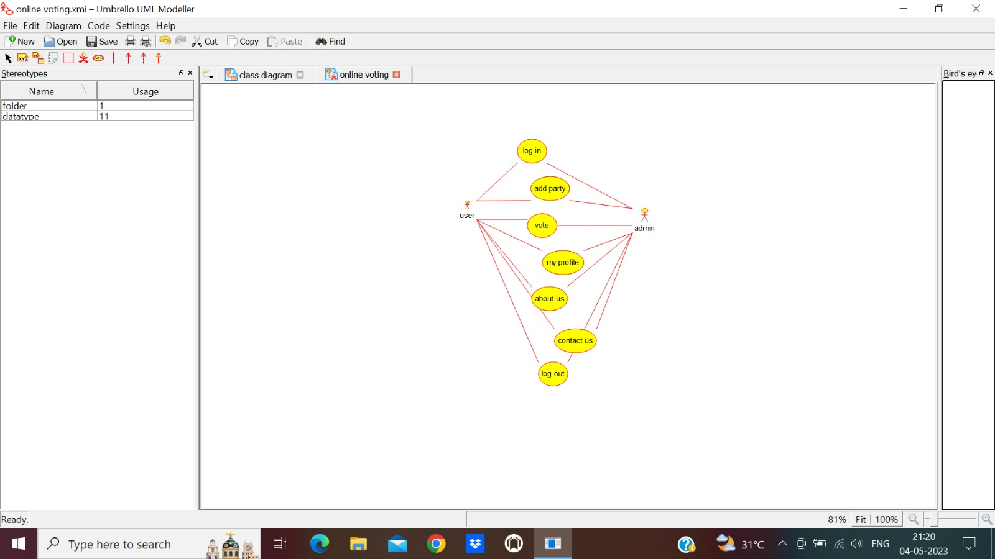

2.AIRPORT TICKET RESERVATION

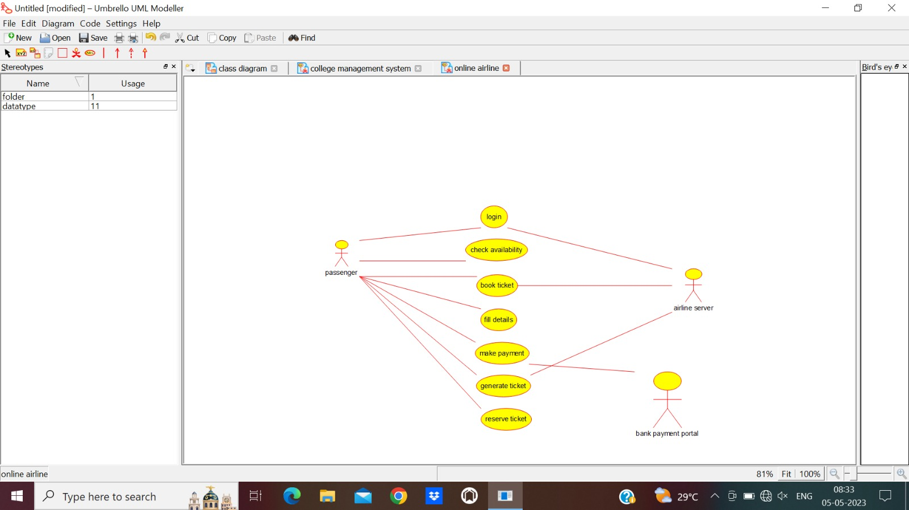

3.BANK MANAGEMENT SYSTEM

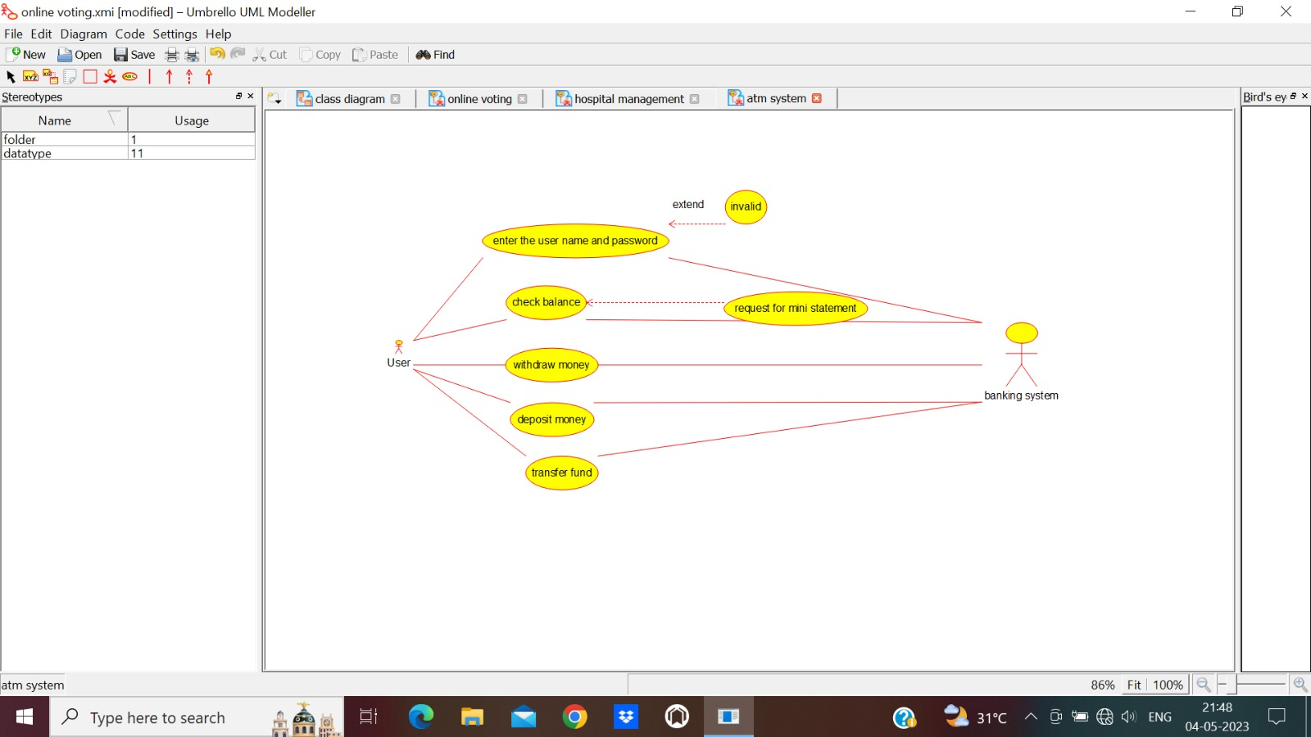

4.COLLAGE MANAGEMENT SYSTEM

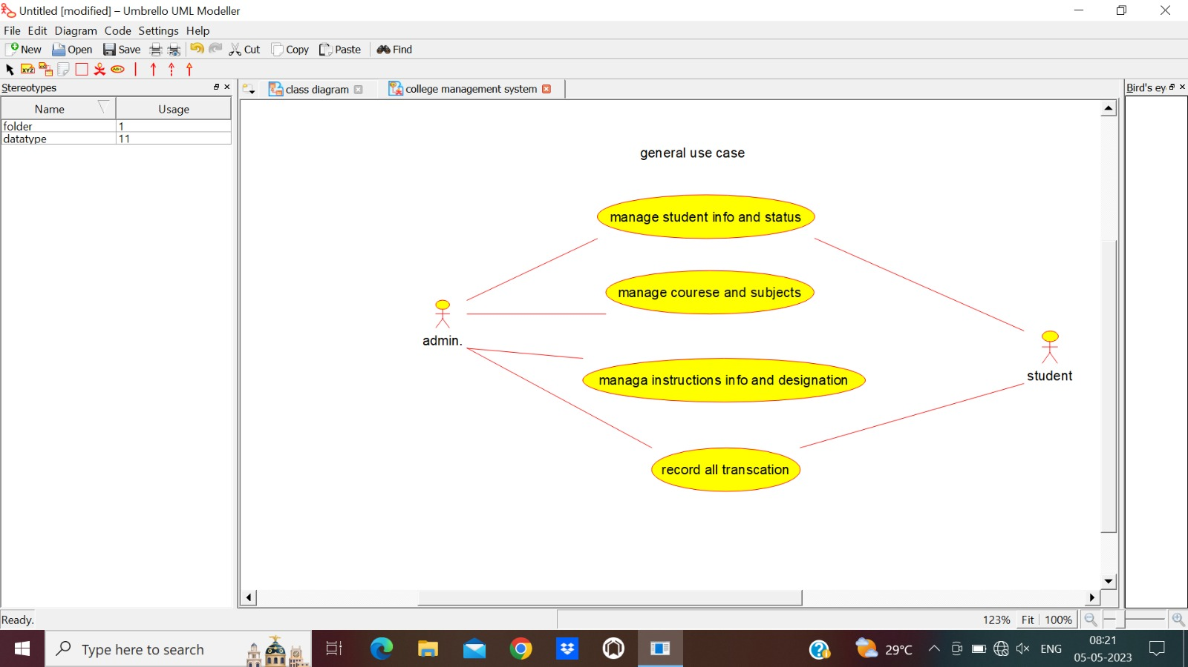

5. HOSPITAL MANAGEMENT SYSTEM

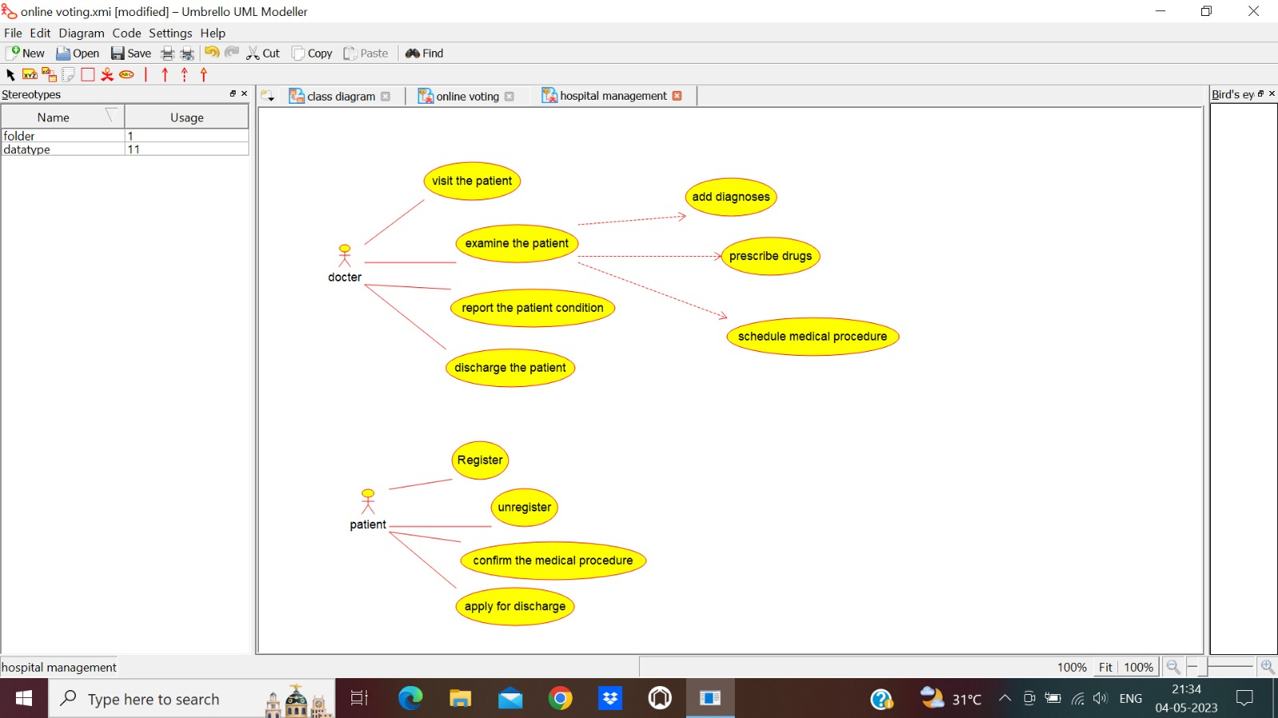

6.LIBRARIAN SYSTEM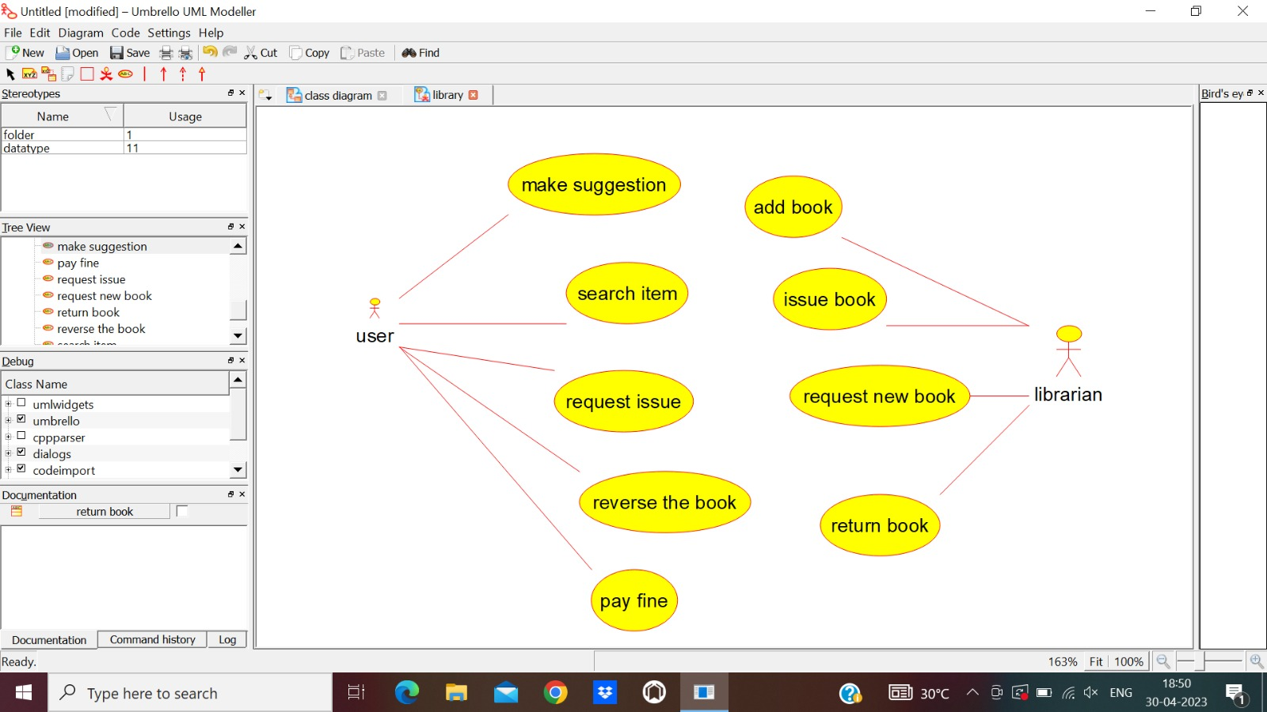

7.ONLINE SHOPPING

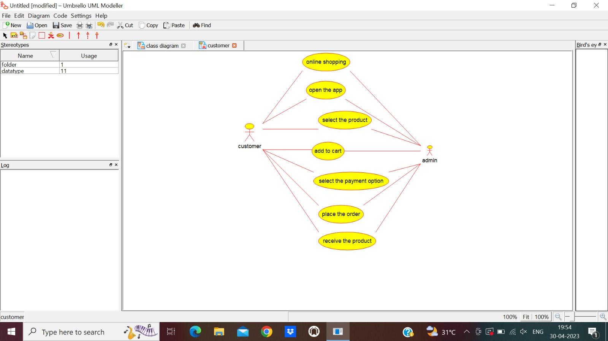

8.RAILWAY RESERVATION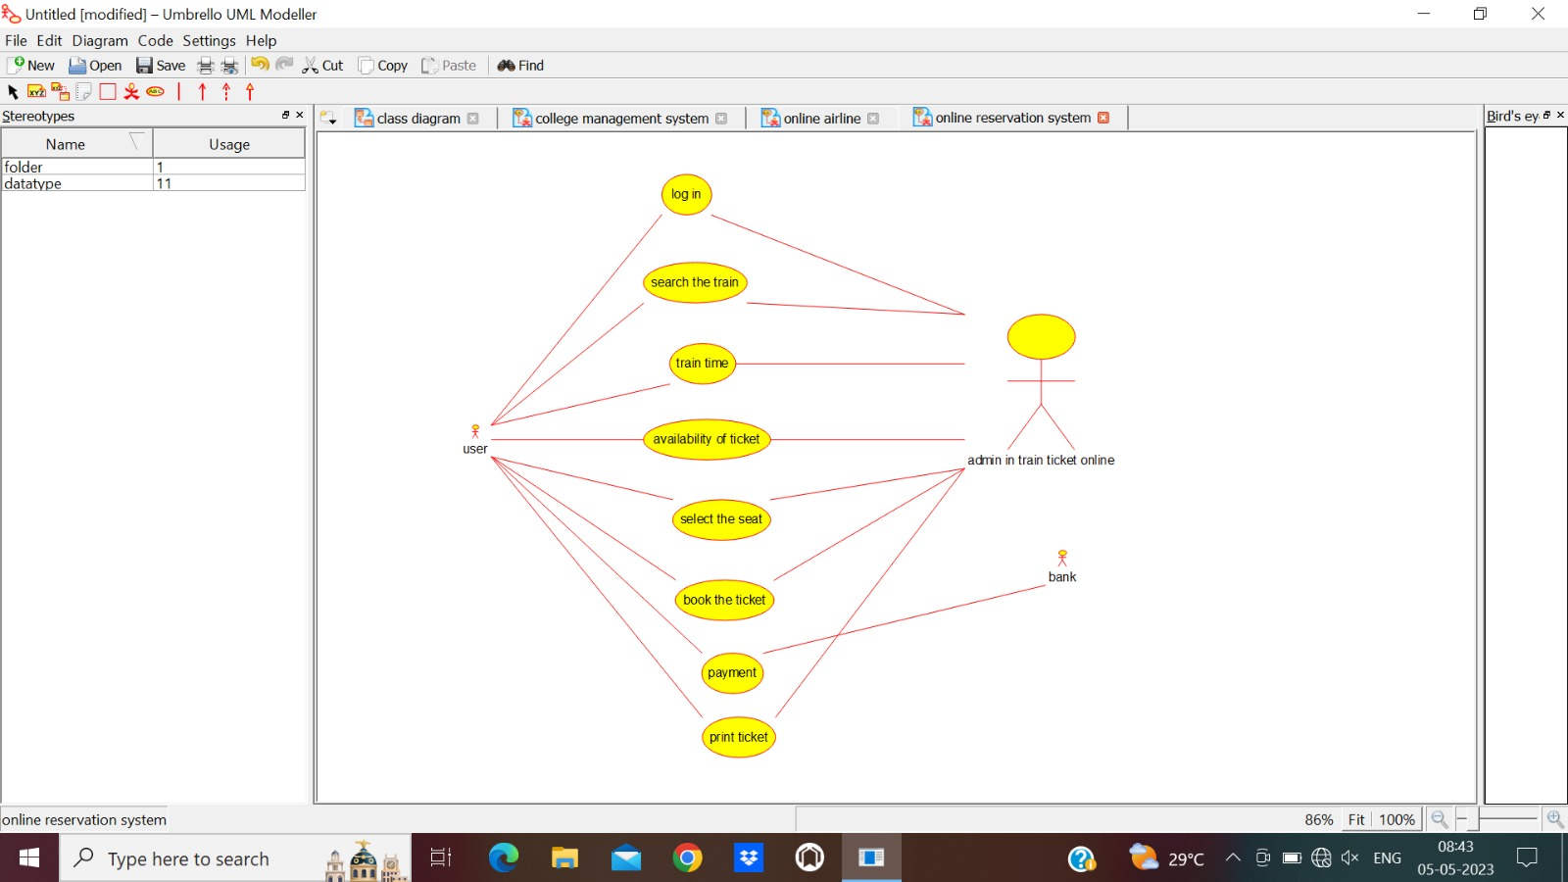

9.SHOPPING CART SYSTEM